FINCORE DIGITAL BANKING MANAGEMENT PLATFORM

MILESTONE 1
MODULES

Account Lifecycle
Balance Management
Statement Generation

Team Members
Bharati Bhat
Ramya Chava
Janhvi Pandey
Indu Patil
Shanmukha Sai
Raziya

Abstract
FinCore Digital Banking Management Platform is a full-stack banking application developed to provide secure and efficient digital banking operations. Milestone 1 focuses on three core functional areas: Account Lifecycle Management, Balance Management, and Statement Generation.
The system uses Angular 22 for the frontend, Java with Spring Boot for the backend, and PostgreSQL for persistent data storage. The backend follows a layered structure consisting of controllers, services, repositories, entities, and data-transfer objects. Secure access is implemented using Spring Security, JWT authentication, and BCrypt password encryption.
The database design contains customer, account, transaction, ledger, statement, and account-status-history tables, together with constraints, sample data, a deposit procedure, and a balance-update trigger. These components provide the foundation for reliable account and transaction management.

2. Introduction
Digital banking systems enable customers to access account information and perform routine banking activities through secure software platforms. A banking management system must maintain accurate customer records, account status, balances, transaction details, and statements while protecting sensitive information.
FinCore is designed as a modular banking platform in which the Angular user interface communicates with Spring Boot REST APIs. The backend applies business logic and security controls, while PostgreSQL stores banking data. Milestone 1 establishes the core account, balance, and statement capabilities required for the platform.

3. Problem Statement
Managing account information, account status, balances, transaction records, and statements through disconnected or manual processes can lead to inefficiency and data inconsistencies. FinCore addresses this problem by providing an integrated platform that maintains customer and account information, supports account lifecycle operations, tracks balances and transactions, and enables statement retrieval and PDF generation.

4. Objectives
- Implement a structured account lifecycle management module.
- Provide secure customer registration and login.
- Create and manage customer-linked bank accounts.
- Support account update, deletion, freezing, and active-account counting operations.
- Provide accurate balance inquiry and recent transaction information.
- Support credit and debit operations with balance updates.
- Maintain transaction records for statement generation.
- Allow users to retrieve statements and download them as PDF files.
- Maintain data integrity through PostgreSQL constraints, relationships, procedures, and triggers.
- Provide a secure and maintainable foundation for future banking modules.

5. Scope of Milestone 1
The scope of Milestone 1 is limited to the following functional modules:
Module | Main Functionality
Account Lifecycle | Customer registration, login, account creation, account updates, account deletion, account freezing, and active-account count.
Balance Management | Balance inquiry, recent transaction retrieval, deposits, withdrawals, pending holds, currency conversion, and balance-related checks.
Statement Generation | Transaction retrieval, statement viewing, date-based statement requests, and PDF statement download.

6. Technology Stack
Category | Technology / Component
Frontend | Angular 22, TypeScript, HTML, CSS
Backend | Java, Spring Boot
Security | Spring Security, JWT, BCrypt
Persistence | Spring Data JPA, Hibernate
Database | PostgreSQL
Frontend PDF/Export | jsPDF, jsPDF AutoTable, XLSX
Build / Package | Maven, npm
Testing | JUnit / Spring Boot test, Angular test setup
API Style | RESTful HTTP APIs

7. System Architecture
FinCore follows a layered architecture that separates the user interface, API controllers, business services, persistence layer, and database.
Angular UI → REST API → Spring Boot Controllers → Service Layer → JPA Repositories → PostgreSQL
The Angular application contains reusable components and services for account lifecycle, balance management, transactions, dashboards, statement preview, and data export. The Spring Boot application separates the three milestone modules into packages and uses DTOs for request data, entities for persistence, repositories for database access, and services for business logic.
The PostgreSQL database provides relational storage and enforces important business constraints. A database trigger updates account balances after transaction insertion, while foreign keys maintain relationships between customers, accounts, transactions, ledgers, statements, and account-status history.

8. Module 1 – Account Lifecycle Management
The Account Lifecycle module manages the relationship between customers and their bank accounts. The backend contains dedicated DTOs, controllers, entities, repositories, and services for account and user operations.

8.1 Customer and User Management
Customer information is represented by the customer entity. It stores first name, last name, email, phone number, address, KYC status, creation time, and password information. A customer can have multiple accounts, represented by a one-to-many relationship.

8.2 Authentication
Users can register and log in using their email and password. During registration, the password is encoded using BCrypt. During login, the encoded password is verified and a JWT token is generated for the authenticated user.

8.3 Account Creation
An authenticated user can create an account. The account is linked to the authenticated customer, initialized with a zero balance, assigned an active status, and recorded with its opening date.

8.4 Account Update
Customer details such as email, name, address, and phone number can be updated through the account lifecycle service.

8.5 Account Deletion and Freezing
The module provides operations for deleting an account and freezing an account using its account number. Freezing changes the account status so that its lifecycle state is explicitly maintained.

8.6 Active Account Count
The system provides an operation to count accounts whose status is Active, supporting dashboard and administrative information.

9. Module 2 – Balance Management
The Balance Management module provides access to account balances and recent transaction information. The backend retrieves an account using its account number and returns the current balance. It also retrieves the latest transactions for the account.

9.1 Balance Inquiry
The current account balance is retrieved from the account record. The database design also maintains an available_balance field to distinguish the usable balance from the ledger balance.

9.2 Recent Transactions
The system retrieves recent transactions associated with an account and maps transaction ID, amount, transaction type, status, transaction date, and remarks into a balance response DTO.

9.3 Deposit and Withdrawal Operations
The frontend balance service supports deposit and withdrawal operations. Deposits increase the account balance, while withdrawals decrease the balance after checking the available spending limit and overdraft eligibility.

9.4 Pending Holds
The balance service supports creation and release of pending holds. Active holds reduce the available balance, while releasing a hold restores the corresponding available amount.

9.5 Balance Controls
- The database prevents negative account balances using a CHECK constraint.
- Transaction amounts must be greater than zero.
- Only CREDIT and DEBIT transaction types are permitted in the database transaction table.
- The frontend checks available balance and overdraft eligibility before withdrawals.
- The frontend provides low-balance and overdraft-related status calculations.

9.6 Currency Support
The frontend balance service supports USD, EUR, GBP, JPY, and CAD display conversions using configured rates.

10. Module 3 – Statement Generation
The Statement Generation module provides transaction-based account statements. Users can request statement information and download a PDF statement.

10.1 Statement Retrieval
The statement service identifies the authenticated customer, verifies the requested account, and maps transaction information into a statement response structure.

10.2 Statement Data
The statement response includes transaction ID, account number, amount, transaction type, status, transaction date, and remarks.

10.3 PDF Generation
The backend creates a PDF document containing an account statement and a tabular representation of transaction information. The generated document is returned as an application/pdf response for download.

10.4 Frontend Statement Features
The Angular application contains statement-related components such as a statement preview modal, transaction table, filtering functionality, financial summary calculations, and export/PDF services.

11. Database Design
PostgreSQL is used as the primary relational database. The database script defines six core tables: customer, account, transaction_details, ledger, statement, and account_status_history.
Table | Purpose
customer | Stores customer identity, contact, address, KYC, and creation information.
account | Stores customer-linked account details, account type, balance, available balance, status, and opening date.
transaction_details | Stores account transactions, transaction type, amount, date, description, and status.
ledger | Stores debit and credit accounting records associated with transactions.
statement | Stores generated statement information and statement date ranges.
account_status_history | Maintains account status changes for lifecycle tracking and auditing.

11.1 Relationships
- One customer can have multiple accounts.
- Each account belongs to a customer.
- An account can have multiple transaction records.
- A transaction can have an associated ledger record.
- An account can have multiple statement records.
- An account can have multiple account-status history records.

11.2 Database Constraints
- Primary keys uniquely identify records.
- Foreign keys maintain relationships between tables.
- Account balance must be greater than or equal to zero.
- Transaction amount must be positive.
- Transaction type is restricted to CREDIT or DEBIT.
- Customer email and phone are defined as unique fields.

11.3 Stored Procedure and Trigger
A PostgreSQL deposit_money procedure inserts a CREDIT transaction for a specified account and amount. The balance_update_trigger executes after a transaction is inserted and automatically updates both balance and available_balance. CREDIT transactions increase balances, while DEBIT transactions decrease them.
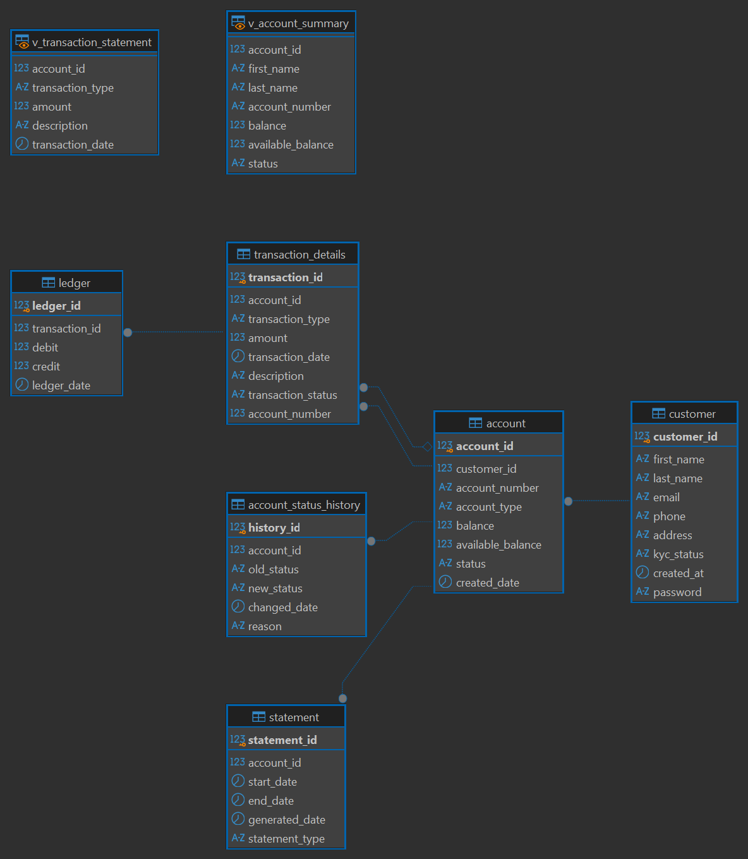
Figure 1:ER Diagram

12. API Design
The backend exposes REST endpoints for authentication, account lifecycle, balance management, and statement generation.
Endpoint | Method | Purpose
/login | POST | Authenticate a user and return a JWT token.
/register | POST | Register a new customer.
/logout | POST | Return a successful logout response.
/dashboard | GET | Protected dashboard endpoint.
/createAccount | POST | Create an account for the authenticated customer.
/deleteAccount | DELETE | Delete an account.
/updateDetails | PUT | Update customer details.
/freezeAccount | PUT | Freeze an account.
/totalAccount | GET | Return the count of active accounts.
/viewStatement | GET | Retrieve statement transaction information.
/downloadStatement | GET | Generate and download a PDF statement.

13. Security Implementation
Security is implemented using Spring Security and JWT. Login and registration endpoints are permitted without prior authentication, while other endpoints require authentication.
- BCryptPasswordEncoder is used for password hashing.
- JWT tokens contain the authenticated user's identity and an expiration time.
- A JWT filter reads the Authorization Bearer token and establishes the Spring Security context when the token is valid.
- Protected endpoints require an authenticated user.
- Customer identity is obtained from the authenticated user's email for account-related operations.

14. User Interface Screens

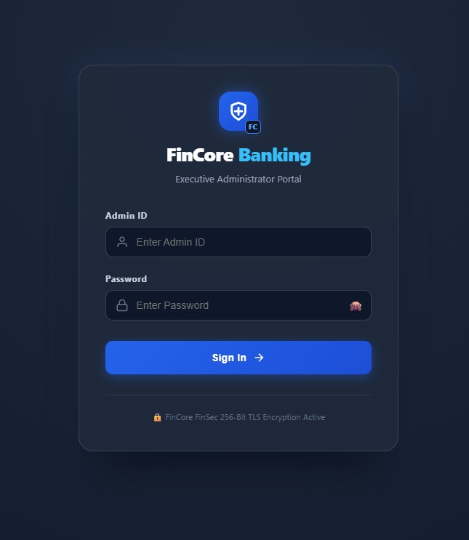
Figure 2:Login Page

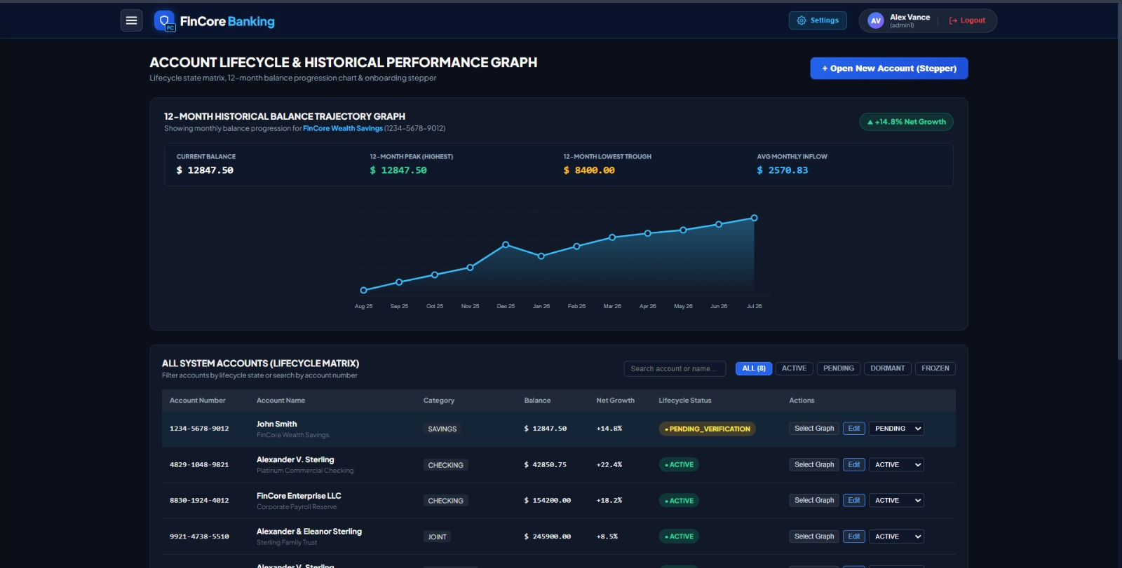
Figure 3:Account Lifecycle
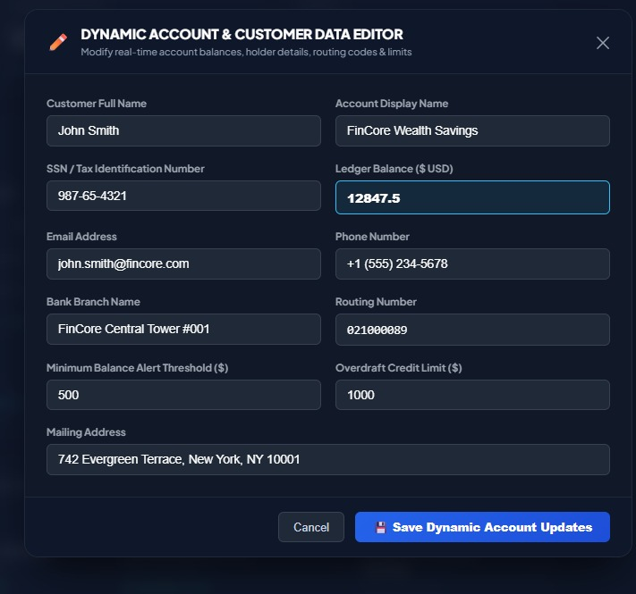
Figure 4:Account Details

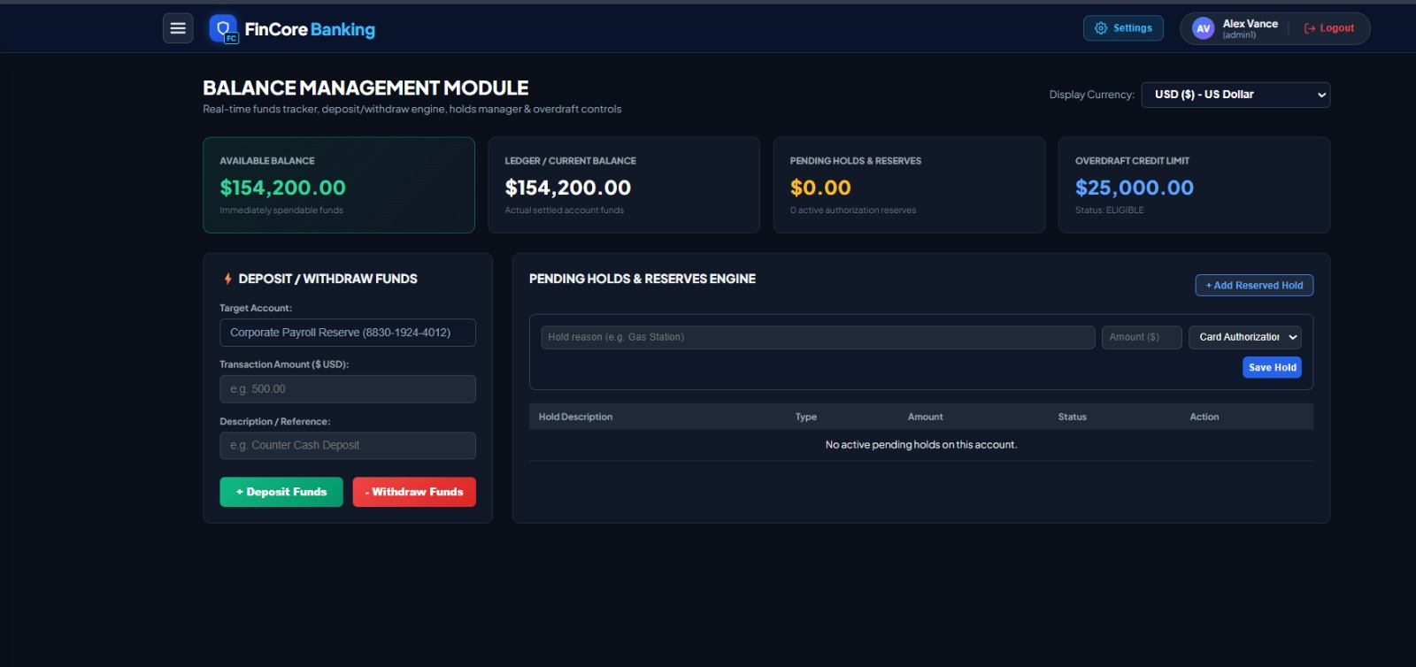
Figure 5:Balance Management
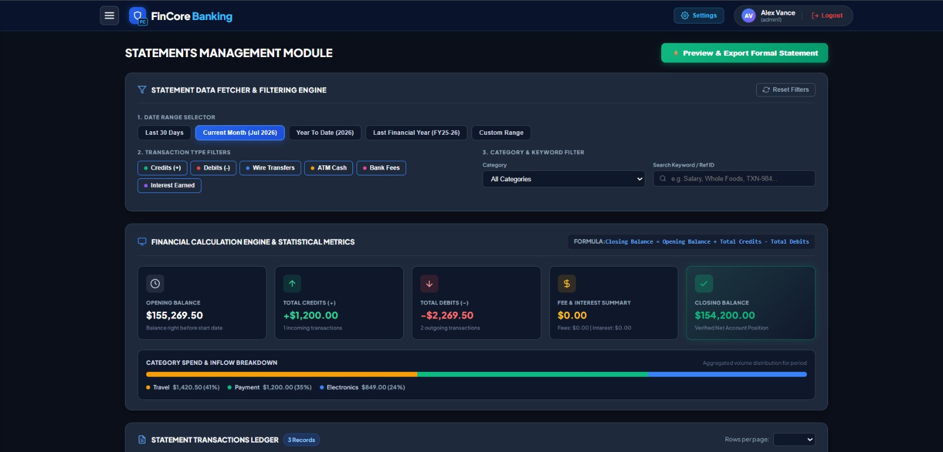
Figure 5:Statement Generation

15. Testing
The project contains a Spring Boot application context test and an Angular test setup. Functional verification can be performed for authentication, account lifecycle operations, balance retrieval and transactions, and statement generation.
Test Area | Expected Result
User registration | Customer is registered and password is stored securely.
User login | Valid credentials return a JWT token.
Invalid login | Invalid credentials are rejected.
Account creation | Authenticated customer receives a new active account.
Account update | Customer information is updated successfully.
Account freeze | Account status changes to Freeze.
Balance inquiry | Current account balance is returned.
Deposit | Credit transaction increases balance.
Withdrawal | Debit transaction decreases balance subject to available/overdraft rules.
Recent transactions | Latest transaction records are returned.
Statement retrieval | Statement transaction data is returned.
PDF statement | Statement is generated and returned as a PDF.

16. Results and Outcomes
Milestone 1 establishes the core functional and technical foundation of the FinCore Digital Banking Management Platform. The implemented modules provide customer authentication, account lifecycle operations, balance management, transaction retrieval, and statement generation.
The PostgreSQL database design strengthens the platform through relational constraints, foreign keys, transaction records, ledger support, statement storage, account-status history, a deposit procedure, and automatic balance-update triggers. The Spring Boot backend and Angular frontend provide a modular structure that can be extended with additional banking functionality.

18. Conclusion
FinCore Digital Banking Management Platform Milestone 1 successfully implements the foundational banking operations required for account and transaction management. The Account Lifecycle module manages customers and account states, the Balance Management module provides balance and transaction functionality, and the Statement Generation module enables transaction-based statement retrieval and PDF generation.
The combination of Angular, Spring Boot, Spring Security, JWT, Spring Data JPA, Hibernate, and PostgreSQL provides a structured architecture for secure and maintainable banking software. The database constraints, relationships, stored procedure, and trigger further support data integrity and automatic balance management.

20. Team Members
Name | Role
Bharati Bhat | Frontend Developer
Ramya Chava | Frontend Developer
Janhvi Pandey | Backend Developer
Indu Patil | Database
Shanmukha Sai | Frontend Developer
Raziya | Backend Developer

